Facility Assessment and Consolidation Analysis

Parchment Public School District

Elementary Facility Modernization and Consolidation Review

Central Elementary School vs. Northwood Elementary School

Evaluates the relative suitability of Parchment Central Elementary School and Parchment Northwood Elementary School for long-term renovation investment, expansion, and potential elementary consolidation planning within Parchment Public School District.
The analysis is based on:
- publicly available district facility information,
- the methodology and priorities outlined in the Michigan Statewide School Facilities Study and Owen Ames Kimball Facilities Assessments (2019 & 2023),
- observable site characteristics,
- operational planning principles,
- enrollment and utilization trends,
- and long-term infrastructure modernization considerations.
Academic performance data was intentionally excluded from this review. The analysis focuses strictly on facilities planning, operational sustainability, and infrastructure investment strategy.
The available evidence presents two competing but legitimate strategic models:
- Centralized District-Campus Model
Prioritizes modernization and expansion at Central Elementary due to its integration within the district core and operational efficiencies associated with centralized services and resources.
- Expansion-Flexibility Model
Prioritizes Northwood Elementary due to its stronger feasibility for phased additions and campus expansion.
The ultimate determination would depend on internal engineering facility assessments, including:
- Facility Condition Index (FCI) scores,
- lifecycle cost projections,
- infrastructure replacement timelines, and repair-versus-replacement modeling.
The evaluation criteria reflect priorities emphasized in the Michigan Statewide School Facilities Study and Owen Ames Kimball Facilities Assessments (2019 & 2023),, including:
- HVAC modernization,
- roofing systems,
- plumbing and electrical infrastructure,
- fire prevention and life safety systems,
- indoor air quality,
- accessibility,
- operational efficiency,
- and long-term cost effectiveness.
The analysis also incorporates:
- campus layout,
- traffic circulation,
- site adaptability,
- construction feasibility,
- and consolidation planning best practices.

Comparative Facility Assessment
Assessment Category | Central Elementary | Northwood Elementary | Observed Advantage
District Campus Integration | Centrally integrated with district core | More geographically separated | Central
Square Footage | 42,500 SQF | 49,000 SQF | Northwood
MSEA Study Energy (2025) | $55,766 Annually | $50,456 Annually | Northwood
Building Age | 1969/300 Wing 1998-2000 | 1939/1952 East & West Wings | Central
Operational Centralization | Strong potential for shared services & resources | More independent neighborhood model | Central
Enrollment Utilization | Higher apparent utilization (285) | Smaller footprint (175) | Central
Long-Term Infrastructure Efficiency | Stronger consolidation efficiencies | More duplicated systems if retained separately (i.e. 2 Boiler rooms) | Central
Site Expansion Flexibility | Stronger expansion flexibility | Less expandability due to constrained residential area | Central
Construction Staging Feasibility | Potentially constrained during additions | Better phased-construction potential | Northwood
Traffic & Circulation Expansion | More complex urban circulation | Easier redesign potential | Northwood
Parking & Drop-Off Expansion | More constrained | Greater flexibility | Northwood
Neighborhood Density Constraints | Tighter surrounding development | Lower-density surrounding land use | Mixed
Early Childhood/Wraparound Integration | More traditional elementary use | Existing Early Learning Center functions | Northwood
Long-Term Scalability | Strong centralized scalability | Strong campus adaptability | Mixed
Renovation Return on Investment | Higher district-wide operational impact | Strong local operational value | Mixed
Potential Construction Disruption | Higher disruption potential | Higher disruption potential | Mixed
2025-2026 Budget Total | $257,354 Amended | $250,154 Amended | Northwood
2026-2027 Budget Total | $ 274,189 Proposed | $ 252,662 Proposed | Northwood
OAK FCA Excellent Total | 0 | 0 | Mixed
OAK FCA Good Total | 80 | 127 | Central
OAK FCA Fair Total | 57 | 37 | Northwood
OAK FCA Poor Total | 12 | 14 | Central
OAK Total Budget Estimate (2023) | $17,271,341 | $14,219,066 | Northwood
OAK Total Budget Estimate (2019) | $6,777,010 | $3,871,565 | Northwood
OAK/Tower FCI Index | 66.7-72.7% | 48.4-52.7% | Northwood
Total FMX Work Requests | 470 | 495 | Central
TREMCO Roof Warranties | 6 until 10/2027 | 7 until 10/2027 | Mixed
Exterior Structure | Brick & | Brick & EIFS-Replacement Suggested FOR EIFS | Central
Fire System | Simplex 4005 FACP (EOL) | Simplex 4005 FACP (EOL) | Mixed
Security Alarm System | Bosch Radionics (EOL) 1994 | Bosch Radionics (EOL) 1994 | Mixed
Asbestos Present | Significant (64 Areas) | Not Significant (11 Areas) | Northwood
Unit Ventilators | End of Life (20+ Units) | End of Life (11) | Northwood
Water Heaters | New Water Heater installed 11/21 | New Water Heater installed 2025 New Wing/1996 in Old Wing | /CentralMixed
Boilers | 3 Patterson Kelly 1998 | 2 Patterson Kelly 1998, 3 Ray Pak 2006 | Central/Mixed
Electrical | 1200 A 208/120V, 3P, 4W | 1600 A 208/120V 3P, 4W | Northwood
Restrooms | Extensive ADA Compliance issues | 3 ADA Compliance issues | Northwood
Division 8 | Windows and Doors needed in all wings except the 300 Wing | Windows in the old wing/Doors in the old wing | Northwood
Plumbing | Significant upgrades needed | Newer in condition with 7 PELC classrooms recently upgraded | Northwood
Cosmetic | Aged, Antiquated appearance | Clean, contemporary appearance with some aged appearance in the Old Wing | Northwood
Sidewalks/Curbs | Repairs Needed | Only minor repairs needed/recent work on PELC back entrance | Northwood
Internal Furnshings | Mixed assortment without consistency/some rooms with cabinets and cubbies others without | Cabinets in all spaces/Furniture more uniform | Northwood
Ceilings | Piping through classrooms/insufficient room for laying ceiling/ no cost effective way to rework | Replacement in Old Wing/New wing is in excellent condition | Northwood
AC | 2 Older RTUs need replacement/All classrooms have window units | Combination of window and floor Units throughout | Mixed
Facility Condition Index Summary
The FCI is a standard industry ratio calculated as:
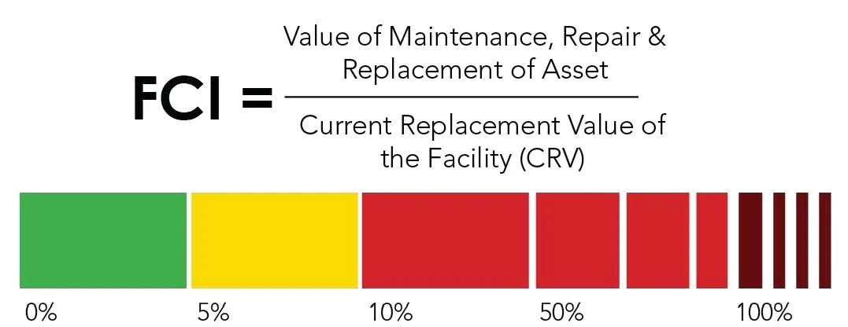
Interpretation Scale:
- 0% – 5%: Excellent
- 5% – 10%: Good
- 10% – 30%: Fair
- 30% – 60%: Poor / Needs Attention
- 60% – Critical / Consider Replacement
Central Elementary’s FCI (Facility Condition Index) score of 66.7% to 72.7% indicates that the building falls into the “Critical/Poor” category, with deferred maintenance costs reaching or exceeding roughly two-thirds of its replacement value.
Based on industry standards, this range indicates the following for the facility:
- Asset Status: The facility is likely experiencing accelerated aging, high rates of failure, and significant deterioration.
- Action Required: Financial analysis often favors replacement over repair at this threshold.
- Operating Reality: Emergency repairs are likely the norm rather than the exception.
Northwood’s FCI (Facility Condition Index) score of 48.4% to 52.7% indicates that the building falls into the "Poor" category, indicating significant deferred maintenance and that the facility is nearing the end of its useful life.
Key Implications:
- Condition: The facility has major building systems failing, with emergency repairs becoming more common.
- Asset Health: The building is undergoing accelerated aging with increasing deterioration.
- Strategy: Immediate investment is required to "reset the clock," likely requiring a mix of proactive & reactive repairs and major capital investment, leading to considerations of whether to replace rather than repair.
The inflation average would be about 4 to 4.5% each year from 2023.

Infrastructure Modernization Considerations
The Michigan Statewide School Facilities Study emphasized modernization priorities including:
- HVAC replacement,
- plumbing systems,
- electrical upgrades,
- roofing systems,
- fire suppression,
- and indoor air quality improvements.
The study repeatedly emphasized that districts should prioritize:
- lifecycle efficiency,
- deferred maintenance reduction,
- and long-term sustainability.
In this context:
- Central may not provide long-term operational efficiency through consolidation,
- Northwood may allow modernization workand upgrades to occur more efficiently during phased additions.
The distinction becomes one of:
- centralized infrastructure efficiency versus
- physical constructability and expansion flexibility.

Early Childhood and Shared Services Integration
Northwood’s role in housing or supporting:
- Early Learning Center functions,
- preschool programming,
- and wraparound childcare operations
indicates the campus already functions as a broader elementary-services hub.
This supports Northwood’s candidacy as:
- a flexible community-services campus,
- or a consolidated elementary center with integrated early childhood programming.
This operational flexibility is a meaningful planning advantage.

Traffic, Parking, and Community Impact
A major elementary consolidation project creates substantial transportation demands.
Compared with Central, Northwood appears to offer:
- more flexibility for bus circulation redesign,
- safer separation of parent and bus traffic,
- larger staging potential,
- and fewer urban traffic constraints.
Central’s tighter neighborhood placement may create:
- congestion concerns,
- limited parking expansion opportunities,
- and more difficult construction sequencing.
However, Central’s location near the district core may improve:
- district-wide accessibility,
- transportation routing efficiency,
and family access from multiple attendance areas

Strategic Planning Scenarios

Scenario A — Centralized District-Campus Model

Potential Strategy
- Retain and modernize Central Elementary
- Consolidate elementary operations around district core
- Reduce duplication of infrastructure systems
- Repurpose or close Northwood

Advantages
- Operational efficiency
- Shared district infrastructure
- Centralized maintenance
- Long-term cost reduction
- Stronger district-campus continuity

Challenges
- More difficult phased construction
- Potential traffic constraints
- Site limitations during expansion

Scenario B — Expansion-Flexibility Model

Potential Strategy
- Expand Northwood Elementary
- Retain North Elementary
- Consolidate operations into fewer elementary sites
- Repurpose or close Central Elementary

Advantages
- Better phased construction feasibility
- More adaptable site layout
- Easier parking and circulation redesign
- Existing early childhood integration

Challenges
- Less centralized district infrastructure
- Potential duplication of operational systems
- Reduced integration with district core

Conclusion
Both elementary campuses present legitimate advantages depending on the district’s long-term strategic priorities.
If the district prioritizes:
- centralized operations,
- district-core integration,
- and long-term infrastructure efficiency,
- expansion feasibility,
- phased construction practicality,
- campus adaptability,
- and future site flexibility,
The final recommendation should ultimately be guided by:
- engineering facility condition assessments,
- lifecycle cost modeling,
- demographic projections,
- and district financial capacity.
Parchment Northwood Elementary School may represent the more practical consolidation campus.

